Solution Architecture
(Incident Lifecycle Automation)
Date | 21 October 2026
Team ID
Project Name | Incident Lifecycle Automation in ServiceNow
Maximum Marks | 4 Marks

Introduction
Solution architecture connects a business problem to the technology that solves it. For this project it explains how the workspace, automation, data, related modules and infrastructure of ServiceNow work together to manage an IT incident from the first report to its documented resolution.
Incidents that arrive through emails or calls are often unclassified, escalated late and poorly tracked. The proposed architecture places the whole lifecycle in the ServiceNow Incident module, so every incident is created, classified, escalated, resolved and learned from in the same controlled way.

Objectives of the Solution Architecture
- Give a clear technical structure for the Incident Lifecycle Automation project.
- Show how each business need maps to a ServiceNow component.
- Describe the flow of data from incident creation to resolution and knowledge capture.
- Support SLA compliance, traceability, security and easy maintenance.
- Leave room to add Problem, Request and other modules later.

Scope of the Solution
- Incident creation by Service Desk agents in the Service Operations Workspace.
- Classification by Category, Subcategory, Urgency, Service, Service Offering and CI.
- Knowledge suggestions through Agent Assist.
- Reassignment to Level 2 support and On Hold handling while a change is pending.
- Emergency change request and child incident creation from the incident.
- Cause and resolution documentation, followed by knowledge article creation.
- SLA and related record tracking.

High-Level Solution Architecture
The diagram below shows the layers of the proposed solution and how they connect.
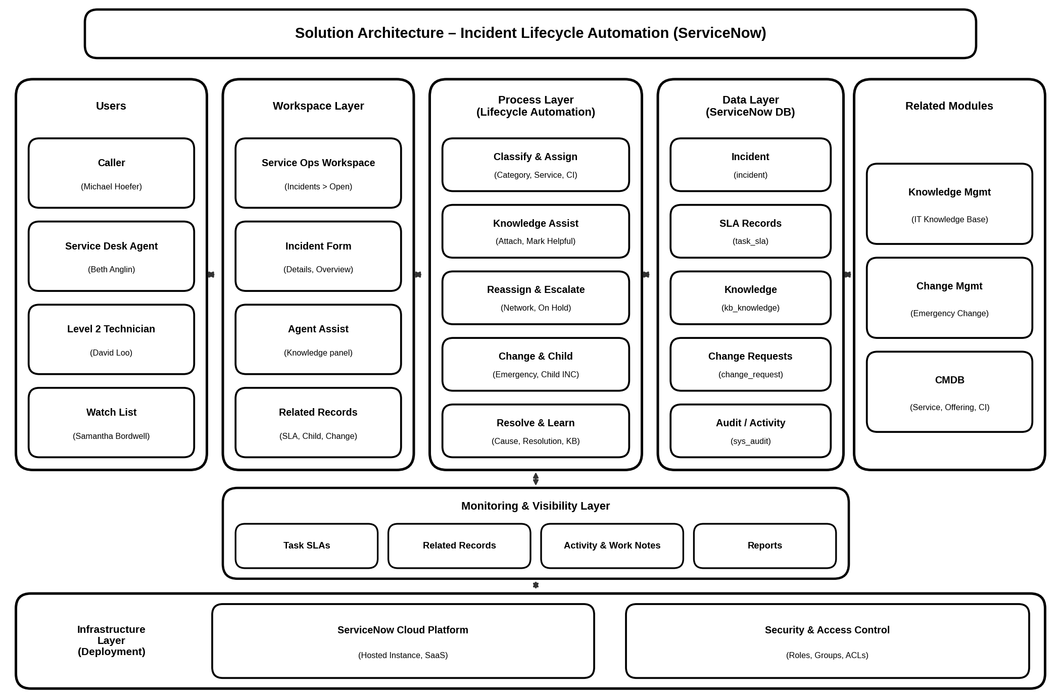
Figure 1: High-Level Solution Architecture

Architecture Description

User Layer
Four kinds of users take part: the caller who reports the problem, the Service Desk agent who logs and classifies it, the Level 2 technician who investigates and resolves it, and watch-list members who follow the updates. Each user sees only what their role needs.

Workspace Layer
The Service Operations Workspace is the single place where incidents are listed, opened and updated. It contains the incident form, the Agent Assist side panel and the Related Records tab for SLAs, child incidents and changes.

Process Layer
This layer carries the lifecycle steps: classifying and assigning the incident, suggesting and attaching knowledge, reassigning to the Network group, putting the incident On Hold for a change, raising an emergency change and child incident, and finally resolving with cause and resolution notes.

Data Layer
The ServiceNow database stores incident records, SLA records, knowledge articles, change requests, CMDB services and configuration items, and the audit history of every update.

Related Modules
Knowledge Management supplies articles to Agent Assist and receives new ones from resolved incidents. Change Management handles the emergency change. The CMDB provides the Service, Service Offering and Configuration Item used for classification.

Monitoring & Visibility
Task SLAs, the Related Records tab, the activity log with work notes, and reports give agents and managers a clear view of progress and SLA status.

Infrastructure & Security
The solution is hosted on the ServiceNow cloud as a SaaS instance, so no local servers are needed. Roles, assignment groups and access controls decide who can view or change each record.

Architecture Components and Functions
Layer / Component | Key Functions
Users | Caller reports the issue, Service Desk agent logs and classifies, Level 2 technician investigates and resolves, and watch-list members follow progress.
Service Operations Workspace | Main working area where agents open the Incidents list, create records and work on them.
Incident Form | Holds the short description, caller, channel, category, subcategory, urgency, service, offering, CI, assignment group and state.
Agent Assist | Suggests knowledge articles, lets the agent mark one helpful and attach it with a comment.
Assignment Groups | Service Desk for first-line handling and Network for Level 2 investigation; reassigning clears the Assigned to field.
Change Management | Receives the emergency change request created from the incident and links it back to the record.
Child Incidents | Track a recurring issue under a parent incident; resolving the parent resolves the child.
Knowledge Management | Creates an article from the resolved incident in the IT knowledge base using the Standard template.
SLA Engine | Starts and tracks the Task SLAs shown under Related Records.
ServiceNow Database | Stores incident, SLA, knowledge, change, CMDB and audit records.
Security & Infrastructure | Roles, groups and ACLs control access; the instance runs on the ServiceNow cloud (SaaS).

Incident Processing Flow
Caller reports issue → Agent creates incident in the Workspace → Classification (Category, Service, CI) → Agent Assist knowledge attached → Reassigned to Network group → Level 2 investigation and CI update → On Hold (Awaiting Change) → Emergency change and child incident → Cause and resolution recorded → Incident resolved → Knowledge article created → SLA and related records verified.

Mapping of Project Milestones
Milestone | Supporting Component
Incident Record Creation | Service Operations Workspace and Incident Form
Incident Classification | Incident Form fields linked to CMDB service, offering and CI
Knowledge Integration | Agent Assist panel with attach and helpful actions
Reassignment & Escalation | Assignment group change to Network and On Hold state
Change Request Creation | Emergency change created from the incident
Child Incident Creation | Related Records tab, child linked to parent
Incident Resolution | Cause, resolution code and notes, then Resolve
Knowledge Creation | Create Knowledge action into the IT knowledge base
SLA & Related Record Validation | Task SLAs and Related Records checked on the parent

Architectural Benefits
- One workspace and one process for every incident.
- Faster resolution through knowledge reuse.
- Clear escalation from Service Desk to Level 2 support.
- Automatic links between incident, change, child incident and knowledge.
- Better SLA compliance and visibility.
- Easy growth by adding services, groups and modules.

